
Remove this

(Add these texts in the right below of ‘Certifications & Registrations’)

Make it auto slidable and put a download button in the right below each certificate to download the certificate in pdf.
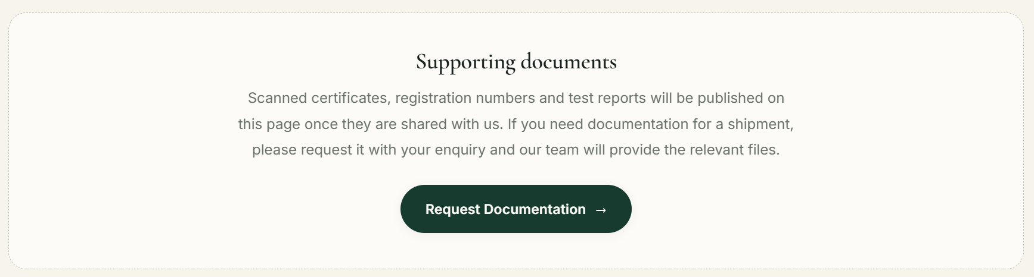
Remove it
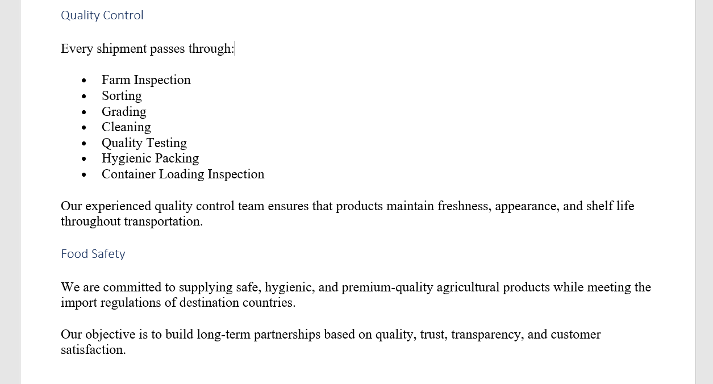
Create a new section and Add this.

Copy this section and past here.
Footer as it is

